# Pushbutton

A pushbutton is a momentary switch that connects or disconnects an electrical circuit when pressed.

**Working Principle:**  
When the button is pressed, it completes the circuit by allowing current to flow between its terminals. When released, the circuit is broken. It is typically used for user inputs.

**Types**:  
- Momentary (Normally Open / Normally Closed)  
- Toggle Pushbutton  
- Illuminated Pushbutton

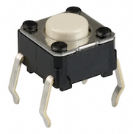**Applications**:   
- User interface controls  
- Reset or power switches  
- Elevator buttons  
- DIY electronics projects

**Advantages**:  
- Simple and reliable  
- Easy to interface with microcontrollers  
- Affordable and widely available

**Disadvantages**: Fig: Push Button  
- Mechanical wear over time  
- Contact bounce (requires debouncing in code)